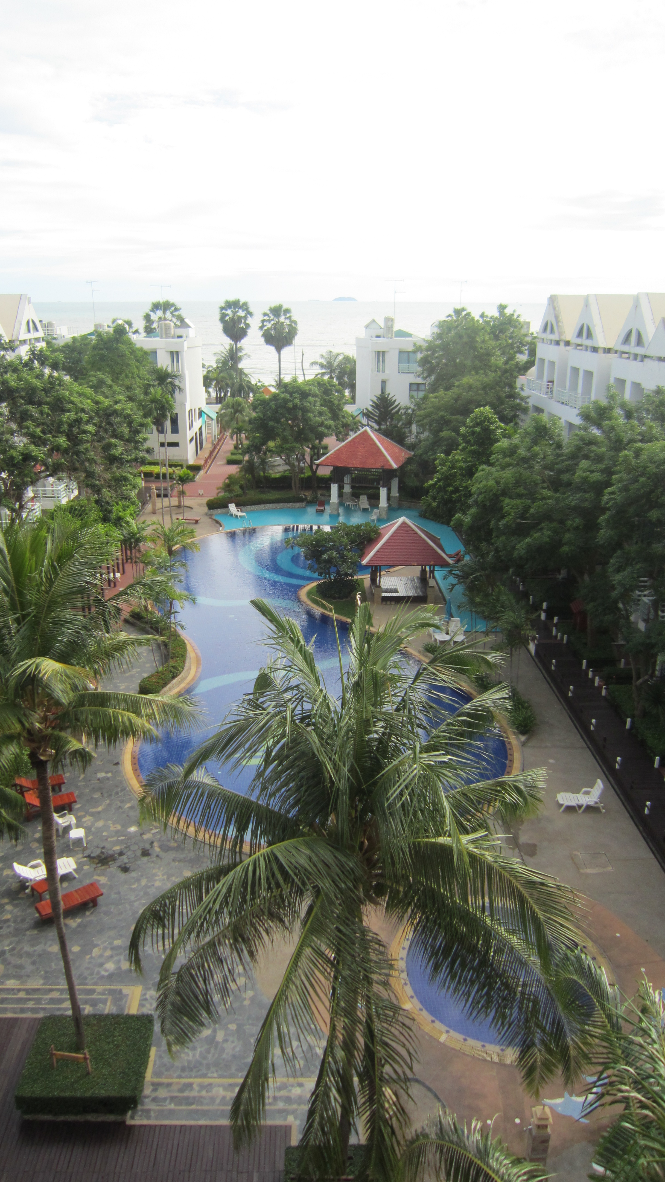

**Jomtien Beach Front Condo 70 sqm Swimming Pool and SeaView  
Studio 4thFloor SoiNaJomtien19   
New Decorated. Fully Furniture Air-condition, TV,Refrigerator.  
Rent : 18,000 Baht/Month  
Sale : 3,200,000 Bath**

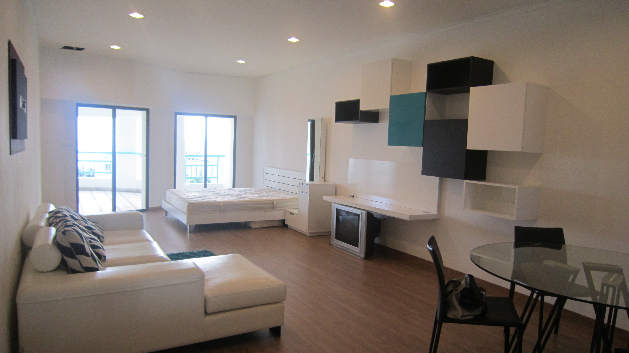

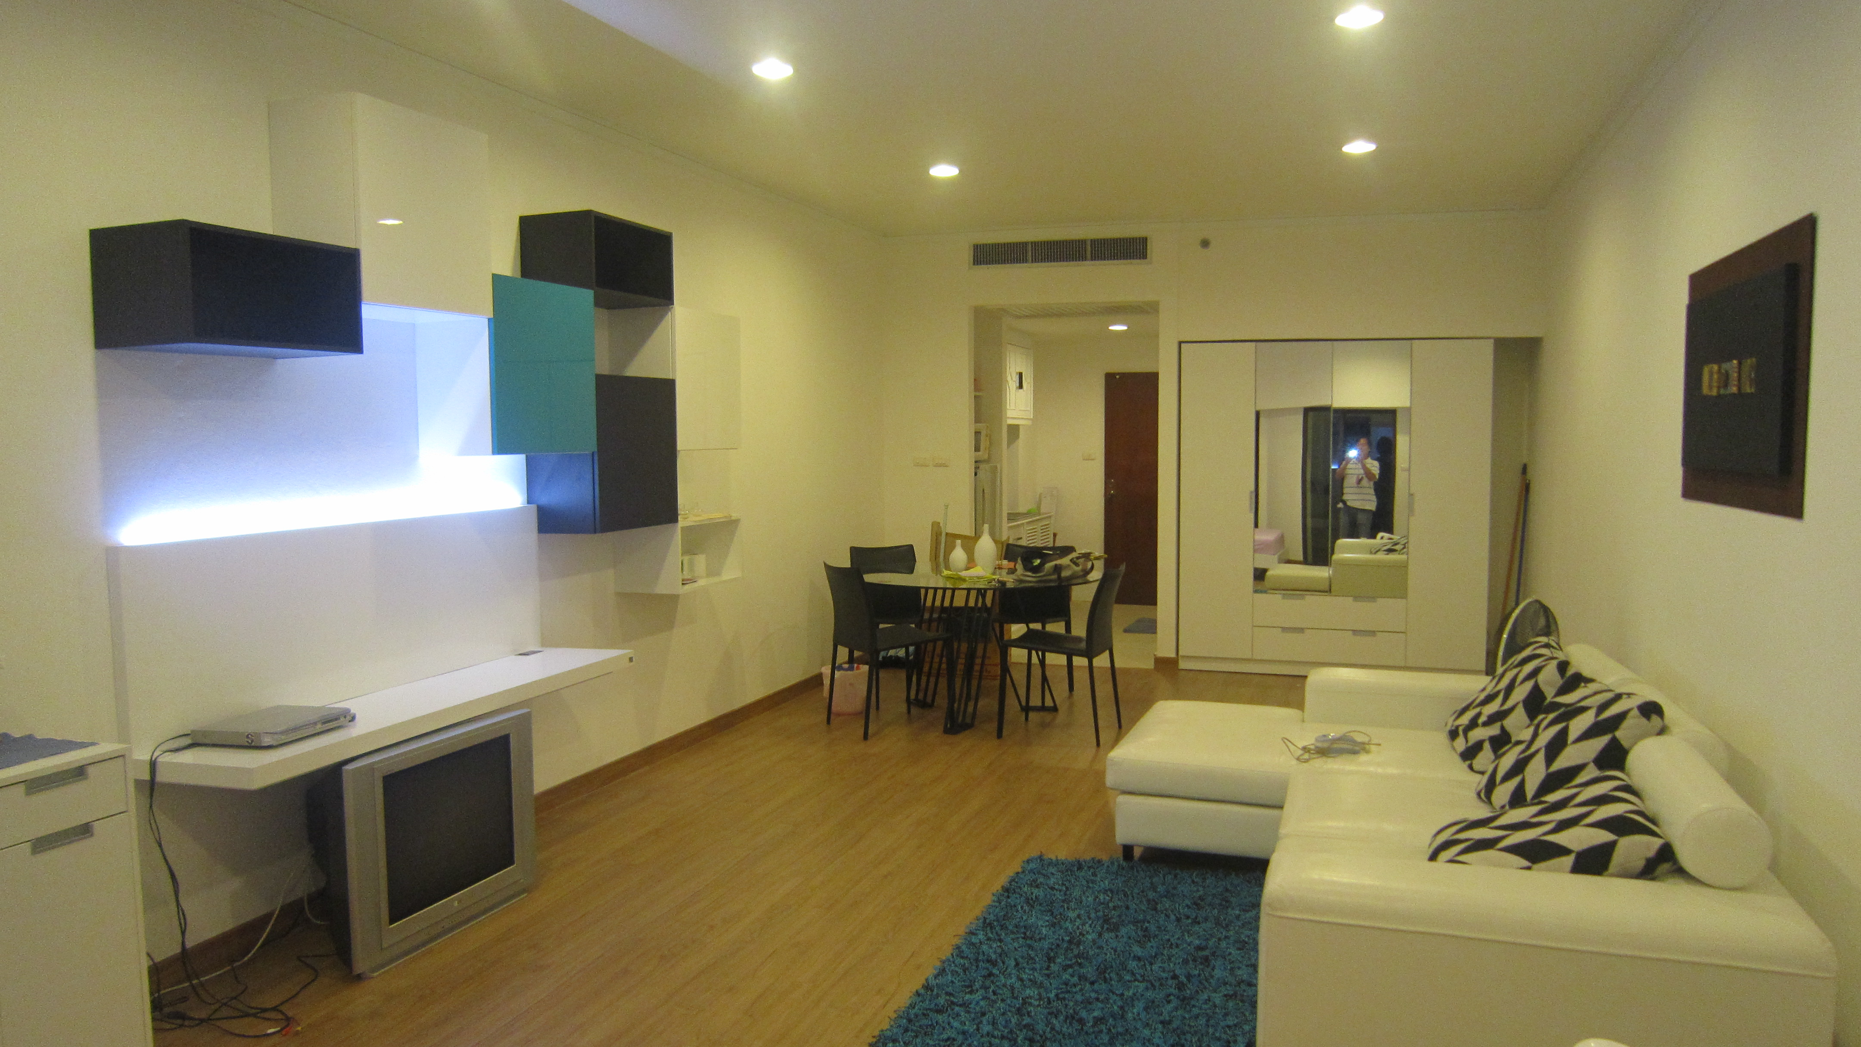

Call : 089-815-0223